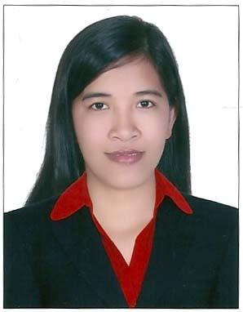
Maria Ofelia B. Manipon
Mobile No: 055-1296124
Villa 11, 25 St., Irani Sabiya,
Jumeirah1, Dubai, UAE.
mafelbmanipon@gmail.com

CAREER OBJECTIVE

I would like to work for a company that will enhance the skills I already have as well as to provide the opportunity for personal and professional growth and advancement opportunities.

SUMMARY OF QUALIFICATIONS

- Bachelor of Science in Computer Science
- Basic Accounting
- English written and oral communication skill proficiency
- Office work adept (record keeping, file handling). Good team player.
- Computer literacy windows-based applications (MS Word, Excel, PowerPoint & AutoCAD)
- Fast learner, responsible and trustworthy.
- Hardworking, patient and able to work on any given task.
- Optimistic. Willing to learn in any kind of work.
- Can work under pressure with quality output.

EXPERIENCE

CLI Finance, Inc Roving Credit Specialist
December 6, 2012 – August 21, 2013

Duties and Responsibilities
- Primarily responsible in screening credit applications based on the standard rules set by the company.
- Endorse recommendation of Credit Applications.
- Market quality clients.
- Ensure completeness and availability of Loan Documents in the report.
- Primarily responsible in securing the specimen signatures of clients whether new applicants or renewals.
- Give detailed history of client's payment pattern or payment history involving other financing companies.
- Formulate and suggest some valuable inputs in marketing strategies, client handling from time to time for effective formulation of branch quarterly plans.
- Ensure completeness and timeliness of all reports.
- Acts as alternate to other credit staff.

CLI Finance, Inc Roving Computer Specialist
August 1, 2010 – December 5, 2012

Duties and Responsibilities
- Provides correct input data in recording, posting and reports preparation, either manual or computerized.
- Daily preparation of check vouchers, checks and collection cards.
- Provides and maintains accurate internal and external quality reportorial requirements.
- Ensures orderly and systematic record keeping.
- Prepares memo, documents using acceptable format for business.
- Provides quality customer service to clients by phone inquiries or walk-ins.
- Prepares timely delinquency monitoring reports and validates delinquency rates and amounts.
- Petty Cash Fund Custodian, ensure proper liquidations and reimbursements of employees.
- Alternate Back Office Specialist or Accounting clerk.

MSWDO Early Childhood Care and Development Service Provider
June 2008 – June 2010

Duties and Responsibilities
- Serves as a teacher among children aging from 2-4, providing basic learning experience among them.
- Serves as a second mother among those children providing love and care while they are in the day care center.
- Participates in social services provided by the Social Welfare and Development Office such as outreach programs, feeding programs, medical missions and others.
- Immediately reports to the Social Welfare and Development Office any acts of violence among children in the community assigned in.
- Provides monthly reports and daily session plans.

ACADEMIC BACKGROUND

March 27, 2007 Bachelor of Science in Computer Science
Graduate National College of Science and Technology
(San Fernando City, La Union, Philippines)

November 15, 2006 – On-the-Job-Training
February 23, 2004 Philippine Veterans Bank
(San Fernando City, La Union, Philippines)

PERSONAL INFORMATION

Date of Birth : December 9, 1986
Gender : Female
Marital Status: Single
Religion : Roman Catholic
Visa Status : Tourist Visa expires on February 18, 2014

REFERENCES AVAILABLE UPON REQUEST

